

| **Title: User interface design using UI tools for mini project** |
| --- |

**______________________________________________________________________**

**Aim:** To enable the students learn different user interface design tools and their aspects

**______________________________________________________________________**

**CO:** Prepare the System Design and Model **______________________________________________________________________**

**Books/ Journals/ Websites referred:**

1. Roger Pressman, “Software Engineering”, sixth edition, Tata McGraw Hill.

**__________________________________________________________________**

**Pre Lab/ Prior Concepts:**

The user interface Need:

System users often judge a system by its interface rather than its functionality. A poorly designed interface can cause a user to make catastrophic errors. Poor user interface design is the reason why so many software systems are never used. Most users of business systems interact with these systems through graphical interfaces although.

GUI characteristics

Windows Multiple windows allow different information to be displayed simultaneously on the user’s screen. Icons different types of information. On some systems, icons represent files; on others, icons represent processes. Menus Commands are selected from a menu rather than typed in a command language. A pointing device such as a mouse is used for selecting choices from a menu or indicating items of interest in a window.

GUI advantages

They are easy to learn and use.

• Users without experience can learn to use the system quickly

The user may switch quickly from one task to another and can interact with several different applications.

Information remains visible in its own window when attention is switched.

Fast, full-screen interaction is possible with immediate access to anywhere on the

**User Interface Design Models**

User model — a profile of all end users of the system

Design model — a design realization of the user model

Mental model (system perception) — the user’s mental image of what the interface is

Implementation model — the interface “look and feel” coupled with supporting information that describe interface syntax and semantics

**User interface design analysis:**

The overall process for analysing and designing a user interface begins with the creation of different models of system function (as perceived from the outside). You begin by delineating the human- and computer-oriented tasks that are required to achieve system function and then considering the design issues that apply to all interface designs. Tools are used to prototype and ultimately implement the design model, and the result is evaluated by end users for quality.

**Study and describe any one user interface tool.**

Figma is a popular web-based user interface (UI) and user experience (UX) design tool used by designers, developers, and teams for creating and prototyping user interfaces for web and mobile applications. Its cloud-based architecture enables real-time collaboration, making it an excellent choice for design teams working on shared projects. Figma supports vector graphics editing, prototyping, and other design tasks, which makes it suitable for creating detailed and dynamic UI components. Figma is accessible on any operating system through a browser, and it also has desktop apps for macOS and Windows.

### Key Features:

1. **Real-time Collaboration**: Figma allows multiple users to work on the same design simultaneously. Designers and stakeholders can review changes and provide feedback in real time, making it ideal for collaborative design projects.
2. **Vector-based Design**: Figma is a vector graphics editor, meaning it can handle scalable designs without loss of quality, crucial for creating responsive UI components.
3. **Prototyping**: Figma allows users to create interactive prototypes without needing any third-party tools. Designers can link different frames to simulate user flows and interactions, providing a dynamic preview of how the interface will function in real life.
4. **Components and Reusability**: Figma allows designers to create reusable components (buttons, menus, icons), which can be maintained consistently across the design system. Updates to a component are automatically reflected across all instances, helping maintain design consistency.
5. **Design Systems**: Figma supports creating and managing design systems. You can store components, styles, and typography in shared libraries, enabling teams to build interfaces that adhere to a unified visual language.
6. **Version Control**: Figma tracks the design history and allows users to access previous versions. This feature is useful for reviewing changes and reverting to earlier states if needed.
7. **Plugins and Integrations**: Figma has a wide variety of plugins for improving productivity, such as icon packs, animation tools, color palettes, and integrations with other design or project management tools like Slack and Jira.
8. **Cross-Platform Access**: Since Figma is web-based, it allows users to access designs from any device or operating system, provided they have an internet connection, enhancing its accessibility.

### User Interface Design Models in Figma:

1. **User Model**: Figma's user model is focused on designers, developers, and stakeholders who need to collaborate on design projects. It caters to both novice and experienced designers, making the tool accessible with a minimal learning curve.
2. **Design Model**: Figma’s design model revolves around the flexibility of vector-based design tools. Designers can create pixel-perfect designs using vector editing, grids, layout guidelines, and constraints. The design model also supports prototyping and interaction design without the need for coding.
3. **Mental Model**: Users of Figma perceive the system as a comprehensive and collaborative design platform. It resembles traditional design tools in terms of the look and feel, with added emphasis on real-time collaboration. The mental model includes expectations of multi-platform availability and cloud-based storage.
4. **Implementation Model**: Figma offers a clean, intuitive user interface with a workspace divided into panels for design layers, components, and properties. It uses a drag-and-drop interface for creating designs and a prototype mode for linking different screens and adding interactivity. The tool follows web-based UI design principles, ensuring a consistent and fluid user experience across different devices.

### Advantages of Figma:

* **Collaboration**: Teams can work on designs in real time, significantly reducing feedback loops and speeding up the development process.
* **Cross-Platform Availability**: Figma can be used on any platform, including Windows, macOS, and Linux, through a web browser.
* **Ease of Use**: Figma’s interface is intuitive and easy to learn for new users. Its drag-and-drop functionality, alongside powerful design tools, allows designers to work efficiently.
* **Consistency in Design**: Reusable components and design systems help maintain design consistency across projects and teams.
* **Prototyping**: Built-in prototyping capabilities eliminate the need for additional software, allowing for fast testing and iteration of UI designs.
* **Plugins and Extensibility**: Figma’s wide array of plugins extends its capabilities and allows for deeper customization and workflow optimization.

### Disadvantages of Figma:

* **Internet Dependency**: Figma's web-based nature means that a stable internet connection is required for uninterrupted access to projects.
* **Performance Issues with Large Files**: Complex or large design files can sometimes cause Figma to slow down, especially on devices with lower specifications.
* **Limited Offline Functionality**: Although desktop apps are available, offline functionality is limited compared to fully offline tools like Adobe XD.

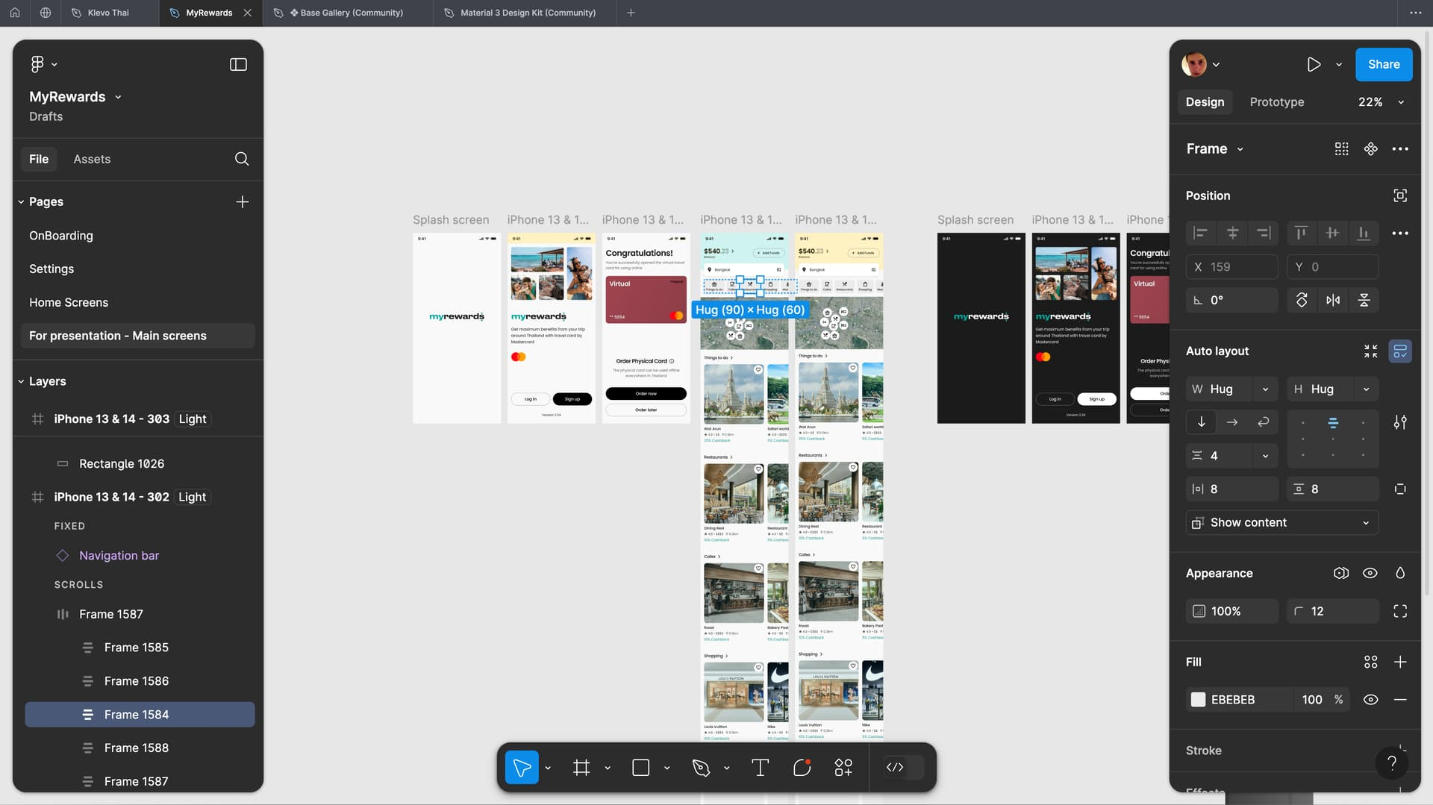

**Figma Design Interface**



**Home Page: Le Miele Mists**

**CONCLUSION:**

**Post Lab Descriptive Questions**

1. State various types of UI design tools.

**Wireframing Tools**: Used for creating low-fidelity, static representations of layouts and flows (e.g., Balsamiq, Mockplus).

**Prototyping Tools**: Tools used to create interactive versions of designs to simulate the final product (e.g., Figma, InVision, Adobe XD).

**Vector-based Design Tools**: Tools used to create high-quality, scalable graphics (e.g., Figma, Sketch, Illustrator).

**UI Component Libraries**: Pre-built design components that can be used to speed up UI design and development (e.g., Material-UI, Ant Design, Bootstrap).

**Code-based Design Tools**: Tools that combine design and development, allowing for real-time code and UI changes (e.g., Webflow, Framer).